
Confidential grade: Serial number：

Battery Storage System MODBUS TCP communication guidance

version/revision number：A/0

Energy Power Research Institution

27/12/2017

文件修改履历表
序号 | 修改内容简述 | 版本/修改 | 修改方式 | 生效日期 | 备注
1 | 初次建立 | V001.00 |  | 2017.12.27

Contents
1.Overview 4
1.1 Objective 4
1.2 range 4
1.3 Copyright statement 5
1.4 terms 5
1.5 Reference materials 5
2.Modbus TCP/IP Introduction 5
2.1 Overall communication structure 5
2.2 Protocol Rules 6
2.3 Massage type 6
2.4 Modbus TCP/IP Data frame encapsulation 7
2.5 MBAP Message header 7
2.6 function code 8
2.7 Data field 9
3. Modbus TCP/IPProtocol Register Table 10
3.1 Register Table Description 10
3.2 Register Table 10
4. Examples of common commands 14
4.1 Energy storage system status introduction 15
4.2 P/Q modo charging/discharging 16
4.3system shutdown 17
5. appendix 18

1. Overview

1.1 Objective
This document describes in detail the BYD Modbus TCP/IP communication protocol format and usage method to ensure that users can effectively monitor the energy storage system using Modbus TCP/IP communication according to this document.

1.2 Range
This protocol stipulates the communication methods between BYD equipment and the upper-level monitoring system.
This protocol applies to BYD container energy storage system, as shown below. The number of ESSs, PCSs and BECUs are based on actual projects.。
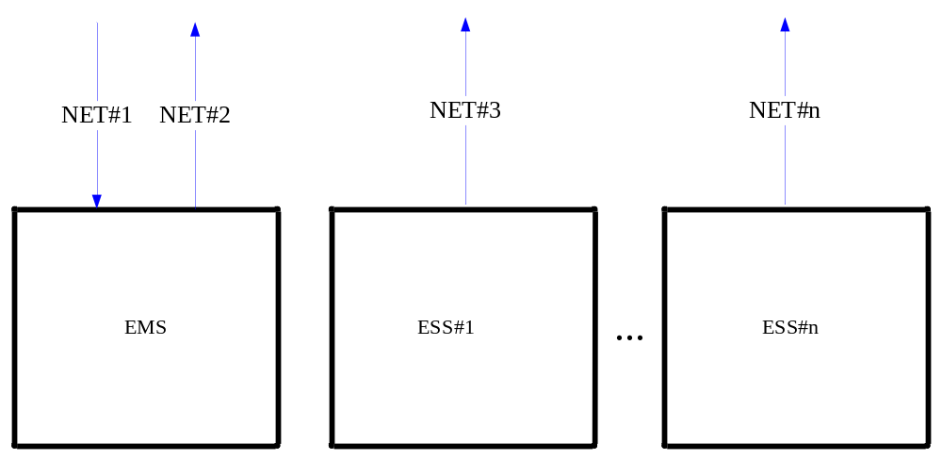
A NET corresponds to a connection in the figure. Connection instructions:
NET#1：Used to monitor the container system, corresponding protocol RPU register table
NET#2： Used to read the overall container information, corresponding to the agreement ADAS register table
NET#3： Used to read single ESS information, corresponding protocol PCS, BECU register table
……
NET#n： Used to read the nth ESS information. For n ESS containers, you need to create n connections to read the information for each ESS

1.3 Copyright statement
Copyright © BYD Auto Industry Co., Ltd. All rights reserved.
The contents of the register table mentioned in the document depend on the specific project. Please refer to the actual project.

1.4 Terms
EMS：Refers to BYD containerized energy storage system。
ESS：Refers to BYD's single energy storage unit
RTU：Refers to BYD remote transmission unit
PCS：Refers to BYD converter, energy conversion system
BECU：BYD battery pack manager
ADAS： BYD auxiliary data acquisition system。

1.5 Reference materials
《Modbus Protocol specification》
《TCP/IP Protocol》

2.Modbus TCP/IP Protocol Introduction

2.1 Overall communication structure
Modbus TCP/IP communication system may include the following different types of devices：
The Modbus TCP/IP client and server devices connected to the TCP/IP network, is with default port number 502
Interconnection equipment, for example: The bridge, router, or gateway interconnected between a TCP/IP network and a serial link subnet, allows the connection between Modbus serial link clients device and server terminal equipment
In the communication system, the user monitoring system/upper computer serves as the client, and BYD's energy storage system serves as the server.
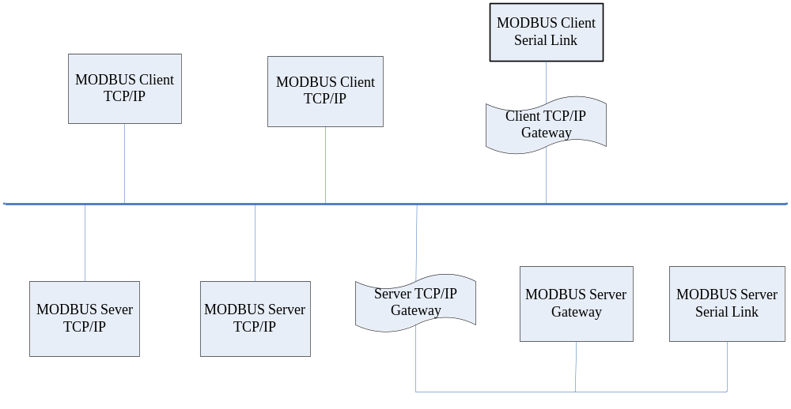
Figure2.1.1 Communication system device type

2.2 Protocol Rules
This is application layer protocol specification which provides the MBAP head, function code, DATA of the application layer in the Modbus TCP/IP protocol. A standard Modbus protocol only supports 16 bits digits Data Mode.

2.3 Message Type
Modbus TCP/IP Message Service exchanges real-time information in Client/Server mode which bases on the following four types message: Modbus Request, Modbus Confirmation, Modbus Indication and Modbus Response. (See Figure 2)
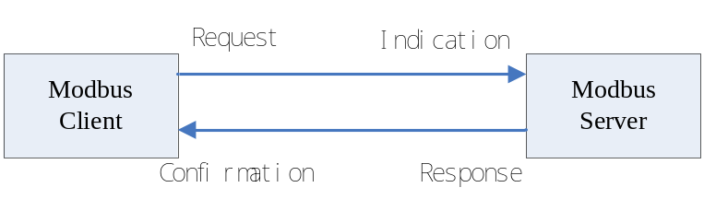
Figure 2
Request: The information sent by Client to begin transaction processing
Indication: The request information received by Server
Response: The response information sent by Server
Confirmation: The response information received by Client

2.4 Modbus TCP/IP Data Frame Package
During the package procedure, Client data are packed in application layer in term of Modbus Application Layer Specification to bring out relevant request or response Protocol Data Unit（PDU）which contains 1 byte function code and more than 2 bytes but less than 252 bytes effective data and then Client will pack 7 bytes MBAP Head to form Application Data Unit（ADU）which is mirrored to other layers according to RFC 1042, and to be added with 20 bytes TCP Head, 20 bytes IP Head, 26 bytes MAC Frame Head and End, 12 bytes Ethernet Message Head and End. All these to make up the whole 80213 Ethernet Message. The maximum length of the message is 338 bytes and the minimum length is 88 bytes. The procedure of the data package and message formation is shown as in Figure 3.
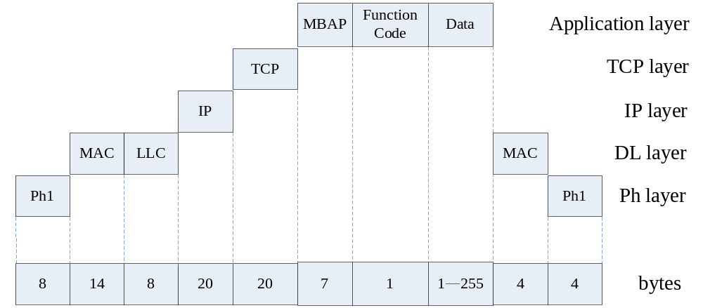

Figure 3

2.5 MBAP Head
MBAP Head is 7 bytes
1）Transaction Processing Identifiers: Used for transaction process matching. Modbus Server will copy the request Transaction Processing Identifiers when response
2）Protocol Identifiers: Used for multiplexing inner system. Identify the Modbus Protocol via value 0
3）Length：The length field is the bytes of the next field, containing Unit Identifiers and Data field
4）Unit Identifiers: Use this field for Router inner system. Specially used for the Gateway which through Ethernet TCP-IP net and Modbus serial link to communicate with the Modbus or the Modbus plus serial link subnet. Modbus Client set this field when request, and the Server must return the same value to this field when response,default Unit Identifiers is 100.
Table 1 MBAP Head
Field | Length | Description | Client | Server
Transaction Processing Identifiers | 2 bytes | The identifiers of the MODBUS request/ response transaction processing | Client starts up | Server copies from the received requests
Protocol Identifiers | 2 bytes | 0 refer to Modbus protocol | Client starts up | Server copies from the received requests
Length | 2 bytes | the bytes of the next field | Client starts up（Request） | Serve (Response) starts up
Unit Identifiers | 1 bytes | The identifiers of the Serial Link or the Remote Slave Station connected to other | bus.  Client starts up | Server copies from the received requests
Note: Unit Identifiers are different in different ESS, and they are available at local HMI. The default address is 100.

2.6 Function Code
The length of the Function Code which is used for informing Slave Station what to perform in Modbus package is 1 byte. The response package of the Slave Station must contain the same function field bytes requested by Master Station. The relevant function codes are referred to Table 1.

Table 1 Function Code List
Function Code | Meanings | Functions
0x03 | Read Register | Obtain one or more current register values inner ESU
0x06 | Set single Register | Write the specified values into a register
0x10 | Set multi Register | Set the value of the continuous register

2.7 Data Field
Modbus Data field is 1-252 bytes long, and it is decided by its idiographic functions.
The most significant bytes of the Register Address and the Writes is ahead，and the least significant bytes is behind. The return Data Field value of the Read Register is U16 type.
Table 2 Read Data Request Message Data Field
Data Field
1st -2nd byte | 3rd -4th byte
The beginning address of the Register | Register numbers
Note：the numbers of the successive Read Register should be no more than 100.
Table 3 Read Data Response Message Data Field
Data Field
1st byte | 2nd- 3rd byte | 4th – 5th byte | 2n– 2n+1 byte
Data bytes numbers | Data 1 | Data 2 | Data n
Table 4 Write Data Request Message Data Field
Data Field
1st -2nd byte | 3rd -4th byte
Register Address | Register Writes

Table 5 Write Data Response Message Data Field
Data Field
1st -2nd byte | 3rd -4th byte
Register Address | Register Writes

3. Modbus TCP/IP Protocol Register List
Register address: the communication data transmission address between BYD ESS system and monitoring system

3.1 Register list Instructions
The register list contains the RTU, PCS, BECU and auxiliary data acquisition system (ADAS) of the energy storage internal system
Since the number of PCS-BECU modules depends on the project capacity, the number of modules contained in one ESS is different. Only the first module (1#PCS, 1#BECU) register address is listed here. If the ESS contains multiple modules, each PCS register address offset is 0x200 and each battery register address offset is 0x800
E.g:
1#PCS address range is 0x1000~0x11FF， 1#BECU address range is 0x6000~0x67FF；
2#PCS address range is 0x1200~0x13FF， 2#BECU address range is 0x6800~0x6FFF；
……and so on, up to 4 PCSs and 4 BECUs。

3.2 Register list
1. RTU address list
Address(HEX) | RO/RW | Name | Data attribute | coefficient | Unit | Instruction | Remark
0x38A0 | RO | System WorkState | u16 | N/A | N/A | 0: Initial
 |  |  |  |  |  | 1: Fault
 |  |  |  |  |  | 2: Stop
 |  |  |  |  |  | 3: Standby
 |  |  |  |  |  | 4: Grid Monitoring
 |  |  |  |  |  | 5: Ready
 |  |  |  |  |  | 6: Running
 |  |  |  |  |  | 7: Debug
0x38A1 | RO | System workmode | u16 | N/A | N/A | 2:P/Q mode
0x38A2 | RO | Discharge limit for  active power | i16 | 1 | kW
0x38A3 | RO | Charge limit for active power | i16 | 1 | kW
0x38A4 | RO | Limit for inductive  reactive power | i16 | 1 | kvar
0x38A5 | RO | Limit for capacitive  reactive power | i16 | 1 | kvar
0x38A6 | RO | System current active power | i16 | 0.1 | kW
0x38A7 | RO | System current reactive power | i16 | 0.1 | kvar
0x38A8 | RO | System SOC | u16 | 1 | %
0x38A9 | RO | Container Run Num | u16 | 1 | 1
0x0500 | RW | System WorkState control command | u16 | N/A | N/A | 2: Stop
 |  |  |  |  |  | 6: Run
0x0501 | RW | Active Power control command | i16 | 1 | kW |  | postive:discharge；negative:charge
0x0502 | RW | Reactive Power control command | i16 | 1 | kvar

2、PCS address list
PCS information list 0x1000-0x2FFF，offset 0x200，up to 4 PCSs information
0x1000~0x11F is for 1#PCS；
0x1200~0x13FF is for 2#PCS；
0x1400~0x15FFis for 3#PCS；
0x1600~0x17FFis for 4#PCS；
Address(HEX) | RO/RW | Name | Data attribute | coefficient | Unit | Instruction | Remark
0x1001 | RO | System WorkState | u16 | N/A | N/A | 0: Initial
 |  |  |  |  |  | 1: Fault
 |  |  |  |  |  | 2: Stop
 |  |  |  |  |  | 3: Hot-standby
 |  |  |  |  |  | 4: Grid Monitoring
 |  |  |  |  |  | 5: Standby
 |  |  |  |  |  | 6: Running
 |  |  |  |  |  | 7: Debug
0x1002 | RO | System workmode | u16 | N/A | N/A | 2:P/Q
0x1003 | RO | 3 phase current active power | i16 | 0.1 | kW
0x1004 | RO | 3 phase current reactive power | i16 | 0.1 | kvar
0x1005 | RO | 3 phase current inspecting power | u16 | 0.1 | kVA
0x1006 | RO | Limit for discharge  active power | u16 | 0.1 | kW
0x1007 | RO | Limit for charge active power | i16 | 0.1 | kW
0x1008 | RO | Positive reactive power limit | u16 | 0.1 | kvar
0x1009 | RO | Negative reactive power limit | i16 | 0.1 | kvar
0x100A | RO | A phase current | i16 | 0.1 | A
0x100B | RO | B phase current | i16 | 0.1 | A
0x100C | RO | C phase current | i16 | 0.1 | A
0x100D | RO | A phase voltage | u16 | 0.1 | V
0x100E | RO | B phase voltage | u16 | 0.1 | V
0x100F | RO | C phase voltage | u16 | 0.1 | V
0x1010 | RO | AB wire voltage | u16 | 0.1 | V
0x1011 | RO | BC wire voltage | u16 | 0.1 | V
0x1012 | RO | CA wire voltage | u16 | 0.1 | V
0x1013 | RO | System frequency | u16 | 0.1 | Hz
0x1014 | RO | DC voltage | i16 | 0.1 | V
0x1015 | RO | DC current | i16 | 0.1 | A
0x1016 | RO | DC power | i16 | 0.1 | kW
0x1017 | RO | A phase IGBT temperature | i16 | 1 | ℃
0x1018 | RO | B phase IGBT temperature | i16 | 1 | ℃
0x1019 | RO | C phase IGBT temperature | i16 | 1 | ℃
0x1040 | RO | PCS warning 0 | u16 | N/A | N/A | See alarm list for details | 1：warning 0：normal
0x1041 | RO | PCS warning 1 | u16 | N/A | N/A | See alarm list for details | 1：warning 0：normal
0x1042 | RO | PCS warning 2 | u16 | N/A | N/A | See alarm list for details | 1：warning 0：normal
0x1043 | RO | PCS warning 3 | u16 | N/A | N/A | See alarm list for details | 1：warning 0：normal
0x1050 | RO | PCS faults 0 | u16 | N/A | N/A | See faults list for more details | 1：faults 0：normal
0x1051 | RO | PCS faults 1 | u16 | N/A | N/A | See faults list for more details | 1：faults 0：normal
0x1052 | RO | PCS faults 2 | u16 | N/A | N/A | See faults list for more details | 1：faults 0：normal
0x1053 | RO | PCS faults 3 | u16 | N/A | N/A | See faults list for more details | 1：faults 0：normal
0x1054 | RO | PCS faults 4 | u16 | N/A | N/A | See faults list for more details | 1：faults 0：normal
0x1055 | RO | PCS faults 5 | u16 | N/A | N/A | See faults list for more details | 1：faults 0：normal

3、BECU address list
BECU information address 0x6000-0xFFFF，offset is 0x800, up to 4 BECU information
0x6000~0x67FF is 1#BECU information；
0x6800~0x6FFF is 2#BECU information；
0x7000~0x77FF is 3#BECU information；
0x7800~0x7FFF is 4#BECU information；
Address(HEX) | RO/RW | Name | Data attribute | coefficient | Unit | Instruction | Remark
0x6001 | RO | Battery string working state | u16 | N/A | N/A | 0:Initial
 |  |  |  |  |  | 1: Fault
 |  |  |  |  |  | 2:Starting
 |  |  |  |  |  | 3:running
 |  |  |  |  |  | 4:faults
0x6002 | RO | Battery string total voltage | u16 | 0.1 | V
0x6003 | RO | Battery string current | i16 | 0.1 | A
0x6004 | RO | Battery string SOC | u16 | 1 | %
Reserved
0x6006 | RO | Battery string average temperature | i16 | 1 | ℃
0x6007 | RO | Battery number with max voltage of the string | u16 | 1 | N/A
0x6008 | RO | max voltage value of the battery cell in the string | u16 | 0.001 | V
0x6009 | RO | Temperature of the max voltage battery cell in the string | i16 | 1 | ℃
0x600A | RO | Battery number with min voltage of the string | u16 | 1 | N/A
0x600B | RO | min voltage value of the battery cell in the string | u16 | 0.001 | V
0x600C | RO | Temperature of the min voltage battery cell in the string | i16 | 1 | ℃
0x600D | RO | Battery number with max temperature of the string | u16 | 1 | N/A
0x600E | RO | max temperature value of the battery cell in the string | i16 | 1 | ℃
0x600F | RO | Voltage of the max temperature battery cell in the string | u16 | 0.001 | V
0x6010 | RO | Battery number with min temperature of the string | u16 | 1 | N/A
0x6011 | RO | min temperature value of the battery cell in the string | i16 | 1 | ℃
0x6012 | RO | Voltage of the min temperature battery cell in the string | u16 | 0.001 | V
0x6013 | RO | Battery string charge current limit | u16 | 0.1 | A
0x6014 | RO | Battery string discharge current limit | u16 | 0.1 | A
0x6015 | RO | Battery string historical lowest charge capacity | u16 | 1 | Wh
0x6016 | RO | Battery string historical highest charge capacity | u16 | 1 | Wh
0x6017 | RO | Battery string historical lowest discharge capacity | u16 | 1 | Wh
0x6018 | RO | Battery string historical highest discharge capacity | u16 | 1 | Wh
0x6040 | RO | Battery string warning 0 | u16 | N/A | N/A | See alarm list for details | 0：normal 1：warning
0x6041 | RO | Battery string warning 1 | u16 | N/A | N/A | See alarm list for details | 0：normal 1：warning
0x6042 | RO | Battery string warning 0 | u16 | N/A | N/A | See faults list for more details | 0：normal 1：warning
0x6043 | RO | Battery string warning1 | u16 | N/A | N/A | See faults list for more details | 0：normal 1：warning

4、ADAS address list

Address(HEX) | RO/RW | Name | Data attribute | coefficient | Unit | Instruction | Remark
0x3410 | RO | Container Immersion state | u16 | N/A | N/A | 1：Immersion happens； 0：Immersion vanishes；
0x3411 | RO | Container fire status | u16 | N/A | N/A | 1：Fire alarm；  0：Fire alarm vanishes；
0x3412 | RO | Emergency stop state of container electronic control cabinet | u16 | N/A | N/A | 1：Sudden stop press down； 0：Sudden stop spin up；
0x3413 | RO | Container grounding fault state | u16 | N/A | N/A | 1：Grounding fault happens； 0：Grounding fault vanishes；
0x3414 | RO | Container door status1 | u16 | N/A | N/A | 1：door opens.； 0：door closes；
0x3415 | RO | Container door status2 | u16 | N/A | N/A | 1：door opens； 0：door closes；
0x3416 | RO | Container air conditioning power supply state | u16 | N/A | N/A | 1：Air conditioning power supply； 0：Air conditioning power shuts down
0x3440 | RO | ADAS warning 0 | u16 | N/A | N/A |  | 1:warning
0x3441 | RO | ADAS warning 1 | u16 | N/A | N/A | See alarm list for details | 0:normal
0x3442 | RO | ADAS warning 2 | u16 | N/A | N/A
0x3450 | RO | ADAS warning 0 | u16 | N/A | N/A | See the fault list in detail | 1:fault
0x3451 | RO | ADAS warning1 | u16 | N/A | N/A |  | 0:normal
0x3452 | RO | ADAS warning 2 | u16 | N/A | N/A
0x3453 | RO | ADAS warning 3 | u16 | N/A | N/A
note：the returned value of the address, marked with reserved in the register list, is 0
- Common command example
Through the address of Modbus TCP/IP register list, the monitoring system can issue control commands to the energy storage system, or query the current operating data of the system.

4.1 Brief introduction to the status of Energy Storage system
The main states of the system are as follows: control mode, working mode, working state
System control mode
The system control modes are divided into three types: remote, local manual, and local automatic.
1）Remote： The system responds to remote control and remote adjustment commands, and does not respond to local interface control and local adjustment commands
2）local manual： The system can respond to local interface control and local adjustment commands, not respond to remote interface remote control and remote adjustment commands
3）local automatic：The system does not respond to remote and local control and remote adjustment commands. It only responds to centralized controller remote control and remote adjustment commands.
Table 6 Remote/local system control permissions
Perform operations  Current control  Mode | Control system by HMI | Control system by remote interface | Change system control mode via HMI | Change the system control mode by remote interface
remote | Uncontrollable | controllable | controllable | Uncontrollable
Local manual | controllable | Uncontrollable | controllable | Uncontrollable
Local automatic | Uncontrollable | Uncontrollable | controllable | Uncontrollable

System operating mode
P/Q mode：Active power, reactive power output
System working status
Work status is divided into six kinds: initial, stop, start, standby, running, fault。
1）initial：The self-test status after the system is powered on
2）stop：After the system passed the self-test。
3）start：The system is running batteries and inverters in sequence。
4）Standby: The preparations for the operation have been completed, the inverter power module is not working, and all contactors of the main power line are engaged.
5）running: The energy storage system can perform energy charging or discharging
6）Fault: The energy storage system stops due to a fault, causing the system to temporarily stop functioning properly。

4.2 P/Q mode charging or discharging
Function description: The system can carry out active power and reactive power output in this mode。
Operating procedures：
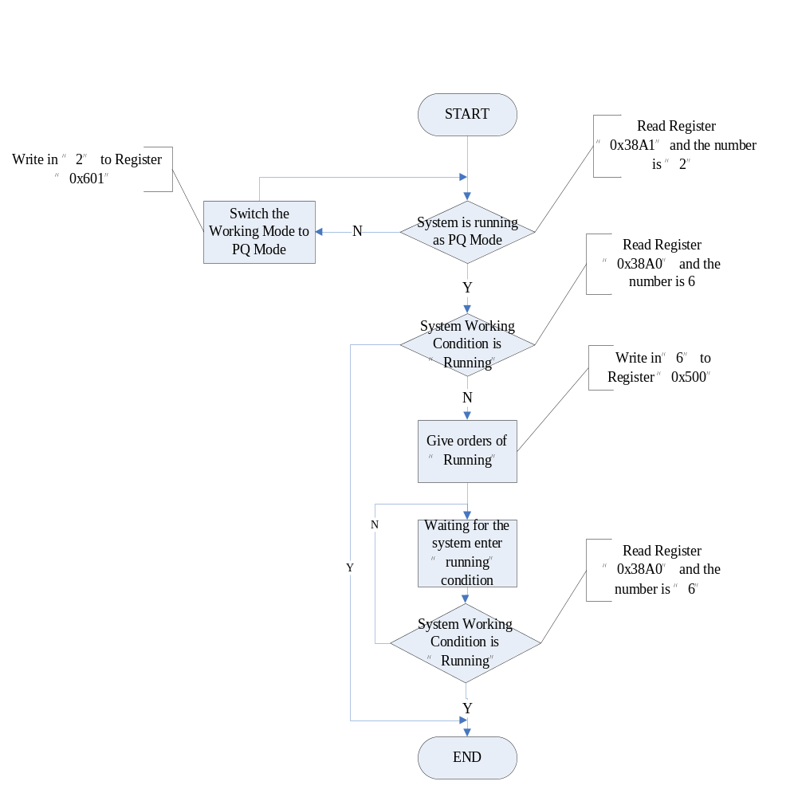
Figure 4.2.1 PQ mode charging/discharging operation procedures

4.3 system stop
Functional Description: Control System stop
Operation procedure:
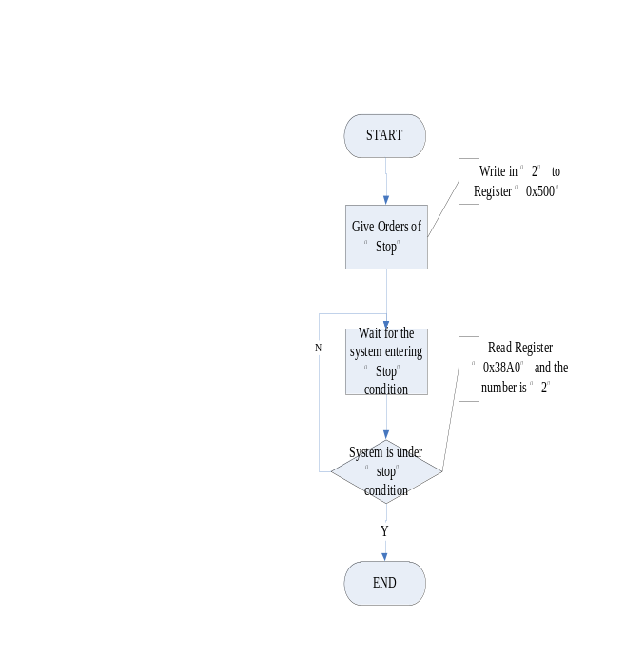
Figure 4.3.1 system stop operation procedure

5. Appendix
System Alarm Fault Code Meaning: Each bit represents an alarm/fault. 0 is normal and 1 is alarm/fault.
The specific meaning depends on the project
- PCS alarm list
PCS0 （0x1040）
code | meaning
0 | DC pre-charging contactor checkback abnormal
1 | Reserved
2 | Reserved
3 | AC pre-charging contactor checkback abnormal
4 | AC main contactor checkback abnormal
5 | AC circuit breaker checkback abnormal
6 | Reserved
7 | Reserved
8 | Reserved
9 | Reserved
10 | Reserved
11 | Reserved
12 | Container door open
13 | Reserved
14 | AC circuit breaker is not closed
15 | Reserved
PCS1 （0x1041）
code | meaning
0 | General overload
1 | Severe overload
2 | Reserved
3 | Over temperature drop power
4 | Reserved
5 | AC three-phase current imbalance alarm
6 | Failed to reset factory settings
7 | Hardware board invalidation
8 | Self-test failure alarm
9 | Receive BMS stop signal
10 | Air-conditioner
11 | IGBT Three phase temperature difference is large
12 | EEPROM Input data overrun
13 | Back up EEPROM data failure
14 | DC circuit breaker checkback abnormal
15 | DC main contactor checkback abnormal
PCS2 （0x1042）
code | meaning
0 | Reserved
1 | Interruption of communication between PCS and Master
2 | Interruption of communication between PCS and unit controller
3 | Reserved
4 | Reserved
5 | Excessive temperature
6 | Excessive humidity
7 | Accept H31 control board signal shutdown
8 | Radiator A temperature sampling failure
9 | Radiator B temperature sampling failure
10 | Radiator C temperature sampling failure
11 | Reactor temperature sampling failure
12 | PCS cabinet environmental temperature sampling failure
13 | DC circuit breaker not engaged
14 | Controller of receive system shutdown because of abnormal command
15 | Reserved
PCS3 （0x1043）
code | meaning
0 | Reserved
1 | Interruption of communication between PCS and RTU0
2 | Interruption of communication between PCS and RTU1AN
3 | Interruption of communication between PCS and MasterCAN
4 | Short-term access too many times to hot standby status in a short term
5 | entry and exit dynamic monitoring too many times in a short term
6 | AC preload contactor delay closure
7 | Reserved
8 | Reserved
9 | Reserved
10 | Reserved
11 | Reserved
12 | Reserved
13 | Reserved
14 | Reserved
15 | Reserved
- PCS faults list
PCS0 （0x1050）
code | meaning
0 | DC pre-charge contactor cannot pull in
1 | AC pre-charge contactor cannot pull in
2 | AC main contactor cannot pull in
3 | Reserved
4 | Reserved
5 | AC breaker is abnormally disconnected during operation
6 | AC main contactor disconnected during operation
7 | Reserved
8 | AC main contactor cannot be disconnected
9 | Reserved
10 | Reserved
11 | Hardware PDP failure
12 | DC midpoint 1 high voltage protection
13 | DC midpoint 2 high voltage protection
14 | Reserved
15 | Reserved
PCS1 （0x1051）
code | meaning
0 | Reserved
1 | Radiator A over-temperature protection
2 | Radiator B over-temperature protection
3 | Radiator C over-temperature protection
4 | Electric reactor core over temperature protection
5 | Reserved
6 | Reserved
7 | DC breaker disconnected abnormally in operation
8 | DC main contactor disconnected abnormally in operation
9 | Reserved
10 | Reserved
11 | Reserved
12 | Reserved
13 | Reserved
14 | Reserved
15 | Reserved
PCS2 （0x1052）
code |  | meaning
0 |  | DC short-circuit protection
1 |  | DC overvoltage protection
2 |  | DC undervoltage protection
3 |  | DC reverse or missed connection protection
4 |  | DC disconnection protection
5 |  | Reserved
6 |  | DC overcurrent protection
7 |  | AC Phase A Peak Protection
8 |  | AC Phase B Peak Protection
9 |  | AC Phase C Peak Protection
10 |  | AC phase A effective value high protection
11 |  | AC phase B effective value high protection
12 |  | AC phase C effective value high protection
13 |  | A-phase voltage sampling Failure
14 |  | B-phase voltage sampling Failure
15 |  | C-phase voltage sampling Failure
PCS3 （0x1053）
code |  | meaning
0 |  | Inverted Phase A Voltage Sampling Failure
1 |  | Inverted Phase B Voltage Sampling Failure
2 |  | Inverted Phase C Voltage Sampling Failure
3 |  | AC current sampling failure
4 |  | DC current sampling failure
5 |  | Phase A over-temperature protection
6 |  | Phase B over-temperature protection
7 |  | Phase C over-temperature protection
8 |  | A phase temperature sampling failure
9 |  | B phase temperature sampling failure
10 |  | C phase temperature sampling failure
11 |  | AC Phase A not fully pre-charged under-protection
12 |  | AC Phase B not fully pre-charged under-protection
13 |  | AC Phase C not fully pre-charged under-protection
14 |  | Non-adaptable phase sequence error protection
15 |  | DSP protection
PCS4 （0x1054）
code |  | meaning
0 |  | A-phase grid voltage serious high protection
1 |  | A-phase grid voltage general high protection
2 |  | B-phase grid voltage serious high protection
3 |  | B-phase grid voltage general high protection
4 |  | C-phase grid voltage serious high protection
5 |  | C-phase grid voltage general high protection
6 |  | A-phase grid voltage serious low protection
7 |  | A-phase grid voltage general low protection
8 |  | B-phase grid voltage serious low protection
9 |  | B-phase grid voltage general low protection
10 |  | C-phase grid voltage serious low protection
11 |  | C-phase grid voltage general low protection
12 |  | serious high frequency
13 |  | general high frequency
14 |  | serious low frequency
15 |  | general low frequency
PCS5 （0x1055）
code |  | meaning
0 |  | Grid A phase loss
1 |  | Grid B phase loss
2 |  | Grid C phase loss
3 |  | Island protection
4 |  | A-phase low voltage ride through
5 |  | B-phase low voltage ride through
6 |  | C-phase low voltage ride through
7 |  | A phase inverter voltage serious high protection
8 |  | A phase inverter voltage general high protection
9 |  | B phase inverter voltage serious high protection
10 |  | B phase inverter voltage general high protection
11 |  | C phase inverter voltage serious high protection
12 |  | C phase inverter voltage general high protection
13 |  | Inverter peak voltage high protection cause by AC disconnection
14 |  | Reserved
15 |  | Reserved
- BECU alarm list
BECU0
code | meaning
0 | Charging overcurrent general alarm
1 | discharging overcurrent general alarm
2 | Charge current over-limit alarm
3 | discharge current over-limit alarm
4 | General high voltage alarm
5 | General low voltage alarm
6 | Abnormal voltage change alarm
7 | General high temperature alarm
8 | General low temperature alarm
9 | Abnormal temperature change alarm
10 | Severe high voltage alarm
11 | Severe low voltage alarm
12 | Severe low temperature alarm
13 | Charge current severe over-limit alarm
14 | Discharge current severe over-limit alarm
15 | Total voltage over limit alarm
BECU1
code | meaning
0 | Balanced sampling abnormal alarm
1 | Balanced control abnormal alarm
2 | Isolation switch is not closed
3 | Pre-charge current abnormal
4 | Disconnected contactor current is not safe
5 | Value of the current limit reduce
6 | Isolation Switch Checkback Abnormal
7 | Over temperature drop power
8 | Pulse charge approaching maximum load time
9 | Pulse charge timeout alarm
10 | Pulse discharge approaching maximum load time
11 | Pulse discharge timeout alarm
12 | Battery string undervoltage
13 | High voltage offset
14 | Low pressure offset
15 | High temperature offset
- BECU faults list
BECU0
code | meaning
0 | Start timeout
1 | Total operating voltage sampling abnormal
2 | BMU Sampling circuit abnormal
3 | Stop total voltage sampling abnormal
4 | voltage sampling line open
5 | Temperature sample line open
6 | Main-auxiliary internal CAN open
7 | Interruption with system controller communication
8 | Reserved
9 | Reserved
10 | Reserved
11 | Reserved
12 | Reserved
13 | Reserved
14 | Reserved
15 | Reserved
BECU1
code | meaning
0 | Reserved
1 | Reserved
2 | Severe high temperature failure
3 | Reserved
4 | Reserved
5 | Reserved
6 | Reserved
7 | Smoke alarm
8 | Fuse failure
9 | Reserved
10 | General leakage
11 | Severe leakage
12 | Reserved
13 | Repair switch disconnected
14 | Emergency stop pressed down
15 | Reserved
- ADAS alarm list
ADAS0 （0x3010）
code | meaning
0 | ups1 Power down
1 | Reserved
2 | Immersion sensor abnormal
3 | Reserved
4 | switch 2 (battery room door) abnormal
5 | switch 1 (PCS room door) abnormal
6 | Firefighting fault
7 | Lightning arrester abnormal
8 | Fire alarm
9 | Fire detector works
10 | pcs1 Ground fault alarm signal
11 | Integrated fire extinguishing
12 | Emergency stop signal
13 | Air conditioning fault contactor signal
14 | pcs1 Ground fault shutdown signal
15 | Reserved
ADAS1 （0x3011）
code | meaning
0 | Reserved
1 | Reserved
2 | Reserved
3 | PCS room ambient temperature sensor failure
4 | Battery room ambient temperature sensor failure
5 | container external ambient temperature sensor failure
6 | The temperature sensor on the top of the control cabinet failed
7 | Reserved
8 | Reserved
9 | PCS room ambient humidity sensor failure
10 | Battery room ambient humidity sensor failure
11 | container external humidity sensor failure
12 | SD card failure
13 | PCS room ambient humidity alarm
14 | battery room ambient humidity alarm
15 | container external humidity alarm
ADAS2（0x3012）
code | meaning
0 | Master Firefighting fault
1 | Reserved
2 | Harmonic protection
3 | Battery emergency stop
4 | Reserved
5 | Reserved
6 | Reserved
7 | Reserved
8 | Reserved
9 | Reserved
10 | Reserved
11 | Reserved
12 | Reserved
13 | Reserved
14 | Reserved
15 | Reserved
- ADAS fault list
ADAS0 （0x3020）
code | meaning
0 | Reserved
1 | Reserved
2 | Reserved
3 | Reserved
4 | Reserved
5 | Reserved
6 | Reserved
7 | Reserved
8 | Reserved
9 | Reserved
10 | Reserved
11 | Reserved
12 | Reserved
13 | Reserved
14 | Reserved
15 | Reserved
ADAS1 （0x3021）
Code | meaning
0 | Reserved
1 | Reserved
2 | Reserved
3 | Serious overheating of ambient temperature in PCS room
4 | Serious overheating of ambient temperature in Battery room
5 | Serious overheating of ambient temperature outside the container
6 | Serious overheating on the top of the electric control cabinet
7 | Reserved
8 | Reserved
9 | Serious overheating of transformer
10 | Reserved
11 | Reserved
12 | Reserved
13 | Reserved
14 | Reserved
15 | Reserved
ADAS2 （0x3022）
code | meaning
0 | DCAC module 1 Communication disconnected
1 | DCAC module 2 Communication disconnected
2 | DCAC module 3 Communication disconnected
3 | DCAC module 4 Communication disconnected
4 | Reserved
5 | Reserved
6 | Reserved
7 | Reserved
8 | BECU1 Communication disconnected
9 | BECU2 Communication disconnected
10 | BECU3 Communication disconnected
11 | BECU4 Communication disconnected
12 | Reserved
13 | Reserved
14 | Reserved
15 | Reserved

